How to apply for a Probationary Certificate
You will need an account on the State Board for Educator Certification (SBEC) website to apply for your certificate. If you do not already have an account, please click on the following link to access instructions for creating one: Instructions for TEAL Registration for TEAL User Account

Log in to your account with SBEC.
- Visit www.tea.state.tx.us
- Select “Educator Login” to login to TEAL

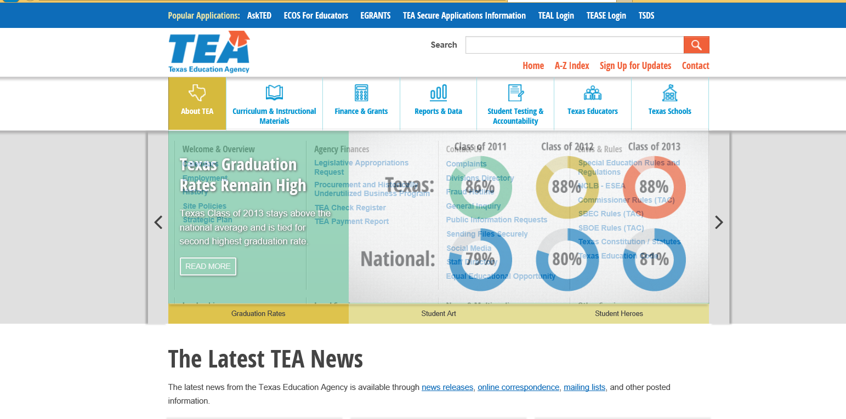

- Enter your Username and Password to log on.

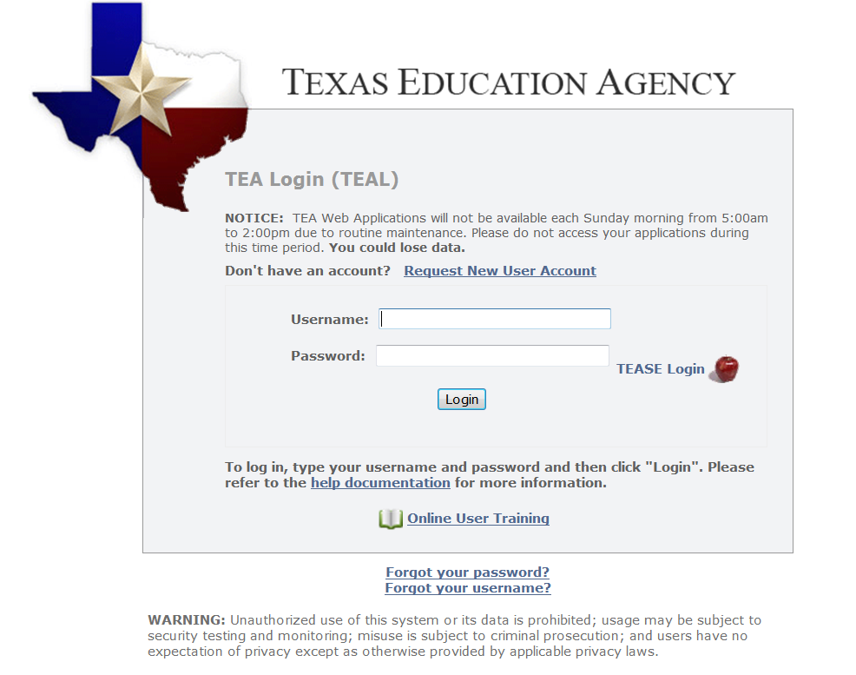

- Click the blue link “Educator” to access your Educator account.

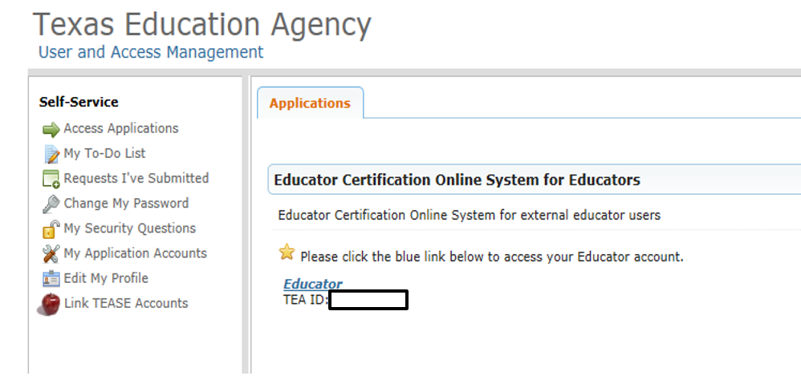

- Set up your Educator Profile or make edits if needed.

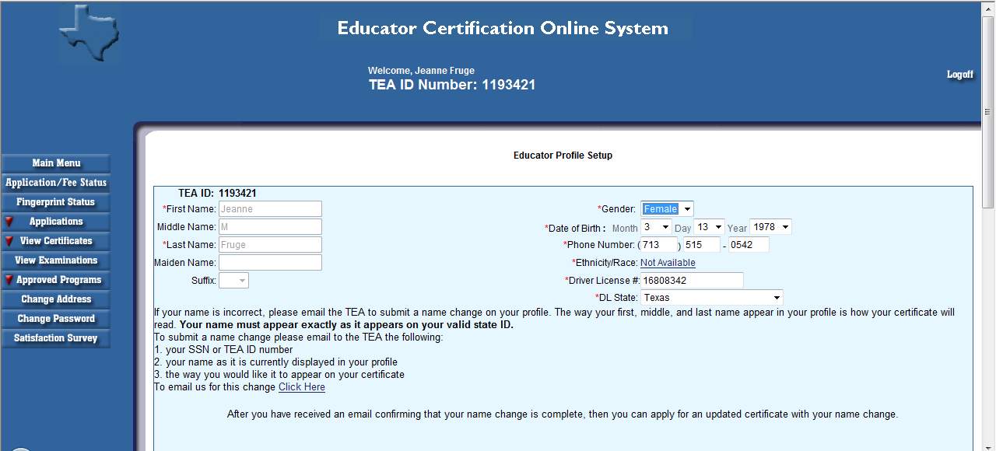

- Press Continue and arrive at the “Educator Main Menu”

- Select “Applications” and then “Probationary Certificate Texas Program”

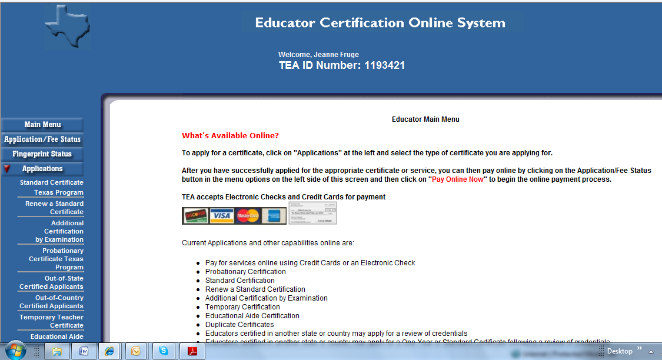

- Have payment method ready, and select “Apply for Certification”

*Please note that this is your PROBATIONARY certificate. This certificate allows you to teach in a Texas classroom during your ACP Internship year. It is not your Standard Teaching Certificate. You will apply for your Standard Certificate upon completion of TE ACP.

- Read, complete, and sign the “Educator Application for Probationary Certificate”. Please pay close attention to the notes embedded below.

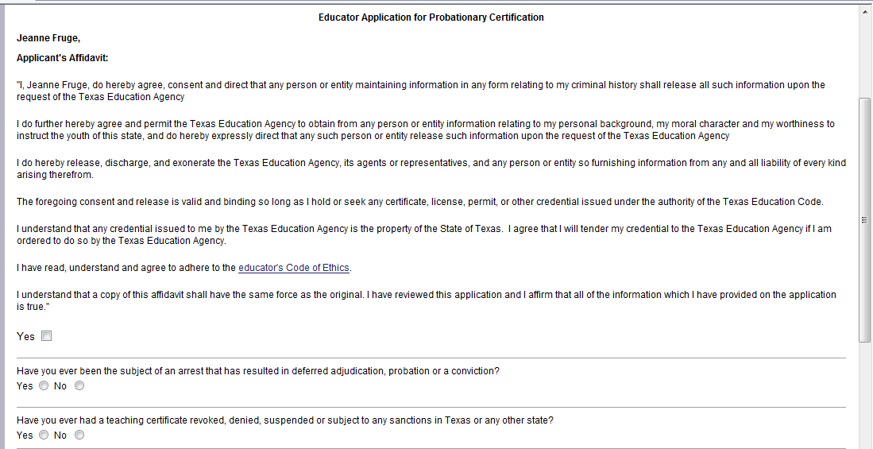

No matter what organization you work for, you must select “YES Prep Public Schools” as the “Entity”.

The “Subject applying for” MUST be the subject for which you have taken and passed your TExES Content Exam.
If you have taken multiple exams, contact the Manager of Certification to ensure you select the correct subject area.

- Select “Apply” and then complete payment of $78. You must complete the payment at the time of the application for the process to be complete.

- PLEASE NOTE: If you have already been fingerprinted with your school district upon hiring, then you DO NOT need to pay for Fingerprinting.

Method of informing TE of receipt of certificate

- Email a “screen shot” (Ctrl+C to copy and Ctrl+V to paste OR use the “snipping tool”) of the certificate to teaching.excellence@yesprep.org by July 25th, 2018. We do not receive notification automatically when you apply.

If you do not complete this process, you will NOT be able to be issued a Probationary Certificate.

